**Atithi Devo Bhava**

Omkar Nishad-28-11910999, Radhika Palamwar-35-11910709,Samruddhi Parate-41-11910900, Sharaddha Paaithanpagare-34-11910930,Nisarg Nibalkar-26- 11910154

Department of Engineering, Sciences and Humanities (DESH)

*Abstract*— This project basically revolves around the most minute details of tourism industry and here we have tried to replicate in graphical format via the use of python giving descriptive analysis of each graph .

# Introduction

Athithi devo bhava the whole project revolves around the vast tourism industry of India and its magnificent aspects that adds up to the economy and GDP of the country n-order to start from the scratch of the ground reality and at the same time making it more realistic and easy to understand we have taken the help of best source to depict the information – the graphs.

# Implementation details

The project is made under the section of data analytics with the use of python by importing pandas that actually help extensively to depict the wholesome chunk of data in form of graph quite easily but yet efficiently .

Below given are the code executed to create every graph

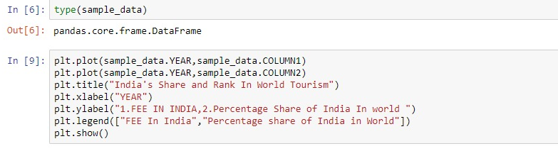

Fig 1-International tourism receipts and India’s share and rank

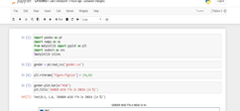

Fig 2- Number of departures from India

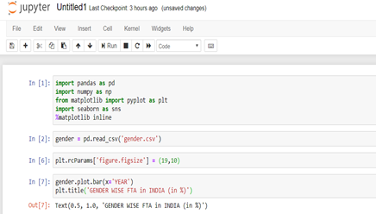

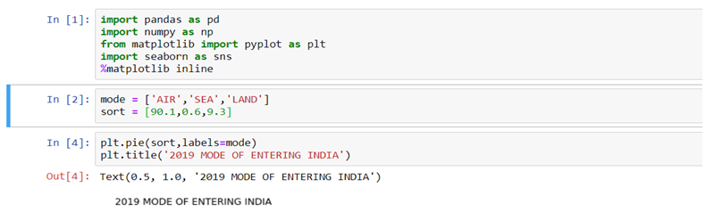

Fig 3 Gender wise foreign tourist arrival in India

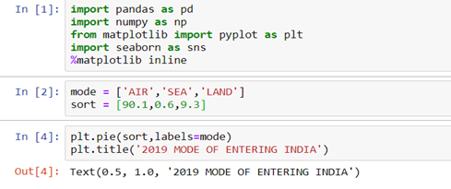

Fig -4 FTA IN INDIA ACCORDING TO MODE OF TRAVEL

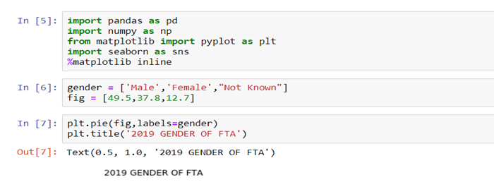

Fig 5-2019 Gender of foreign tourist arrivals

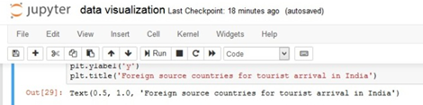

Fig 6 Foreign source countries for tourist arrival in India

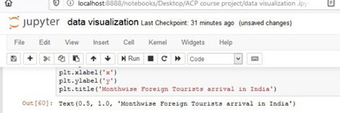

Fig 7-Month wise tourist arrival in India



Fig 8-Month wise foreign tourist income in India

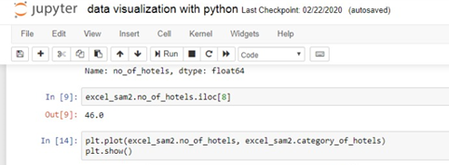

Fig 9- No. Of Hotels

# Results and discussion

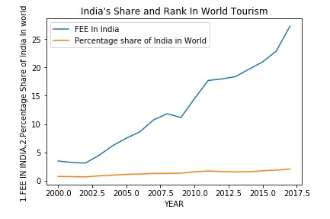

Fig 1-International tourism receipts and India’s share and rank

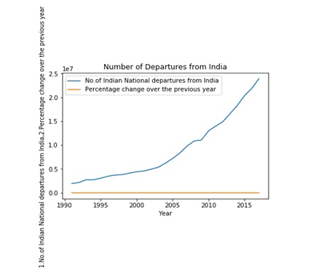

Fig 2- Number of departures from India

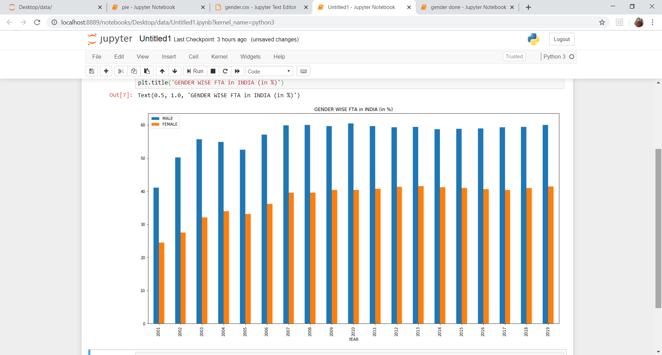

Fig 3 Gender wise foreign tourist arrival in India

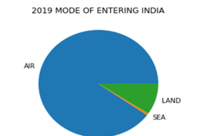

Fig -4 FTA IN INDIA ACCORDING TO MODE OF TRAVEL

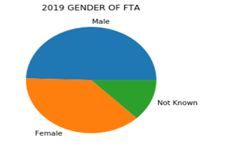

Fig 5-2019 Gender of foreign tourist arrivals

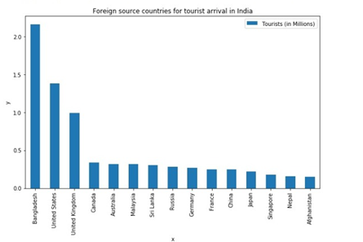

Fig 6 Foreign source countries for tourist arrival in India

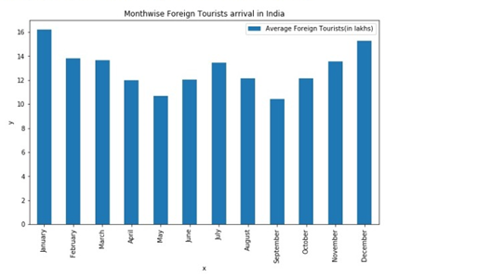

Fig 7-Month wise tourist arrival in India

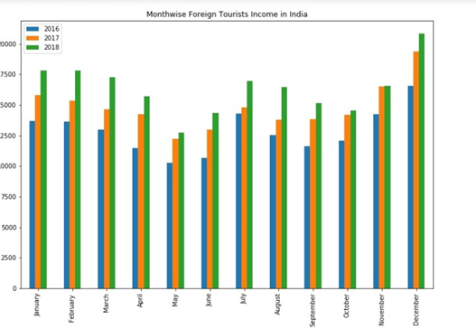

Fig 8-Month wise foreign tourist income in India

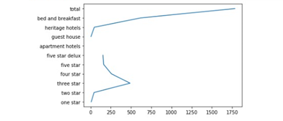

Fig 9- No. Of Hotels

CONCLUSION AND FUTURE SCOPRE

Tourism Industry in India is actually bright however we have a tendency to do have an extended road ahead.

Development of quality infrastructure are the key to India's harnessing full commercial enterprise potential. The

Ministry of commercial enterprise has been terribly corroboratory to the fraternity efforts, and currently visa on

arrival is slowly turning into a reality. In next few decades in india there will be 90 operative airport in different

parts of India. There will be job creation 9 lakhs job and in India till 2024 there will be 2 Million job every year

will be in demand directly or indirectly related to Tourism Industry . There lots of Skilled and unskilled worker

need for tourism Industry.

.

##### References

1. <https://ourworldindata.org/tourism>
2. www.youtube.com
3. [www.github.org](http://www.github.org)
4. Cultural Heritage of Jammu and Kashmir / K. Warikoo - 2009
5. 2. Heritagescapes and Cultural Landscapes / Rana P B Singh (Ed.) & William Logan (foreword) – 2011
6. www.indiastat.com

Indian Tourism Minsitry

**.**

. **.**